

For Immediate Release: August 22, 2019

TAYLOE PIGGOTT GALLERY ANNOUNCES NEW EXHIBITION

WITH ARTIST PAUL VILLINSKI

Exhibition Dates: August 28 – October 5, 2019

Opening Reception: Friday, September 6th, 5-8pm

Tayloe Piggott Gallery is pleased to present a new exhibition with Paul Villinski at the Gallery’s Project Space. Paul Villinski is a sculptor of international note who has created studio and large-scale artworks for more than three decades. A pilot of sailplanes, paragliders, and single-engine airplanes, metaphors of flight and soaring often appear in his work. With a lifelong concern for environmental issues, his work frequently re-purposes discarded materials, effecting surprising and poetic transformations. Tayloe Piggott Gallery will celebrate the opening of this new exhibition at the annual Palates and Palettes Gallery Walk held on Friday, September 6th from 5-8pm. All are invited to attend.

This new exhibition at Tayloe Piggott Gallery complements the gallery’s upcoming exhibition at the inaugural Jackson Hole Fine Art Fair, which will also showcase Villinski’s work. The art fair will run from September 12th - 15th at the Snow King Events Center. Bringing over 50 galleries from around the country, the Jackson Hole Fine Art Fair will exhibit important works by hundreds of respected artists. Tayloe Piggott Gallery is proud to support the flourishing arts community in Jackson as well as the remarkable artistic talent that will unite here in our hometown from around the country. Villinski will curate his work in the Tayloe Piggott booth as well as participate in an interview and award ceremony on Friday, September 13th from 2-3PM in the Snow King Theater. Celebrating the recent release of Vivant Book’s publication on Paul Villinski, Becky and Mia Benenate (founders of Vivant Books) will join Tayloe Piggott Gallery in their booth (128 & 143) with Paul Villinski Limited Edition art books for sale.

About the Artist

His work has been included in numerous exhibitions nationally, recently including the solo exhibitions “Paul Villinski: Burst” at the McNay Art Museum in San Antonio, TX and “Passage: A Special Installation,” at the Blanton Museum, University of Texas, Austin. Recent group shows include “Material Transformations” at the Montgomery Museum of Art, Montgomery, AL; “Re: Collection,” at the Museum of Arts and Design, New York, NY; “Making Mends,” at the Bellevue Museum of Arts, Bellevue, WA; and “Prospect .1,” an international Biennial in New Orleans, LA. “Emergency Response Studio,” a FEMA trailer transformed into an off-the-grid mobile artist’s studio, was the subject of a solo exhibition at Rice University Art Gallery, Houston, TX; the exhibition also travelled to Ballroom Marfa, in Marfa, TX; Wesleyan University’s Zilkha Gallery, Middletown, CT; and the trailer was featured in the New Museum’s “Festival of Ideas for the New City”, in New York, NY.

Villinski’s work is widely collected, including major public works created by commission. His studio recently completed “SkyCycles,” three full-scale “flying bicycles” to be installed at “Ocean Breeze,” a new Parks and Recreation Track and Field facility, through the New York City Percent for Art Program. The City of New Haven Percent for Art Program commissioned “Dreamdesk,” a flying school desk with 18’ wingspan which was installed at the entrance to the East Rock Magnet School in 2014. Permanent collections include the National Soaring Museum, Elmira, NY; the Museum of Arts and Design, NY; the New Orleans Museum of Art, LA; the Virginia Museum of Fine Art, Richmond, VA; Miami International Airport; the Museum of Contemporary Art, Jacksonville, FL; and the University of Michigan Mott Children’s and Von Voitlander Women’s Hospital, Ann Arbor, MI. Corporate collections include Fidelity Investments; Microsoft; Progressive Insurance; the Cleveland Clinic; ADP; McCann Erickson International; New York Life; Ritz-Carlton and many others. He has been a recipient of a National Endowment for the Arts grant, and has been an Artist-in-Residence at the Serenbe Institute, GA; Socrates Sculpture Park, NY; the Millay Colony, NY; the Ucross Foundation, WY; the Djerassi Foundation, CA; and the Villa Montalvo Arts Center, CA. He is represented in New York by Morgan Lehman Gallery; in New Orleans by Jonathan Ferrara Gallery; in Jackson Hole, Wyoming by Tayloe Piggot Gallery; and in Palm Desert, California, by Austin Art Projects.

His work has frequently been reviewed in periodicals including ARTnews; Artforum; Art in America; Sculpture; Interior Design; Design Bureau; New York Magazine; ID; The New York Times; Wall Street Journal; Los Angeles Times; Washington Post; Houston Chronicle; International Herald Tribune; Village Voice; Seattle Times; New Haven Register; Toronto Star; Times-Picayune and many others.

Media Contact:

Sophie Schwabacher

TAYLOE PIGGOTT GALLERY

T: 307.733.0555

[sophie@tayloepiggottgallery.com](mailto:sophie@tayloepiggottgallery.com)

About the Artist

His work has been included in numerous exhibitions nationally, recently including the solo exhibitions “Paul Villinski: Burst” at the McNay Art Museum in San Antonio, TX and “Passage: A Special Installation,” at the Blanton Museum, University of Texas, Austin. Recent group shows include “Material Transformations” at the Montgomery Museum of Art, Montgomery, AL; “Re: Collection,” at the Museum of Arts and Design, New York, NY; “Making Mends,” at the Bellevue Museum of Arts, Bellevue, WA; and “Prospect .1,” an international Biennial in New Orleans, LA. “Emergency Response Studio,” a FEMA trailer transformed into an off-the-grid mobile artist’s studio, was the subject of a solo exhibition at Rice University Art Gallery, Houston, TX; the exhibition also travelled to Ballroom Marfa, in Marfa, TX; Wesleyan University’s Zilkha Gallery, Middletown, CT; and the trailer was featured in the New Museum’s “Festival of Ideas for the New City”, in New York, NY.

Villinski’s work is widely collected, including major public works created by commission. His studio recently completed “SkyCycles,” three full-scale “flying bicycles” to be installed at “Ocean Breeze,” a new Parks and Recreation Track and Field facility, through the New York City Percent for Art Program. The City of New Haven Percent for Art Program commissioned “Dreamdesk,” a flying school desk with 18’ wingspan which was installed at the entrance to the East Rock Magnet School in 2014. Permanent collections include the National Soaring Museum, Elmira, NY; the Museum of Arts and Design, NY; the New Orleans Museum of Art, LA; the Virginia Museum of Fine Art, Richmond, VA; Miami International Airport; the Museum of Contemporary Art, Jacksonville, FL; and the University of Michigan Mott Children’s and Von Voitlander Women’s Hospital, Ann Arbor, MI. Corporate collections include Fidelity Investments; Microsoft; Progressive Insurance; the Cleveland Clinic; ADP; McCann Erickson International; New York Life; Ritz-Carlton and many others. He has been a recipient of a National Endowment for the Arts grant, and has been an Artist-in-Residence at the Serenbe Institute, GA; Socrates Sculpture Park, NY; the Millay Colony, NY; the Ucross Foundation, WY; the Djerassi Foundation, CA; and the Villa Montalvo Arts Center, CA. He is represented in New York by Morgan Lehman Gallery; in New Orleans by Jonathan Ferrara Gallery; in Jackson Hole, Wyoming by Tayloe Piggot Gallery; and in Palm Desert, California, by Austin Art Projects.

His work has frequently been reviewed in periodicals including ARTnews; Artforum; Art in America; Sculpture; Interior Design; Design Bureau; New York Magazine; ID; The New York Times; Wall Street Journal; Los Angeles Times; Washington Post; Houston Chronicle; International Herald Tribune; Village Voice; Seattle Times; New Haven Register; Toronto Star; Times-Picayune and many others.

Media Contact:

Sophie Schwabacher

TAYLOE PIGGOTT GALLERY

T: 307.733.0555

[sophie@tayloepiggottgallery.com](mailto:sophie@tayloepiggottgallery.com)

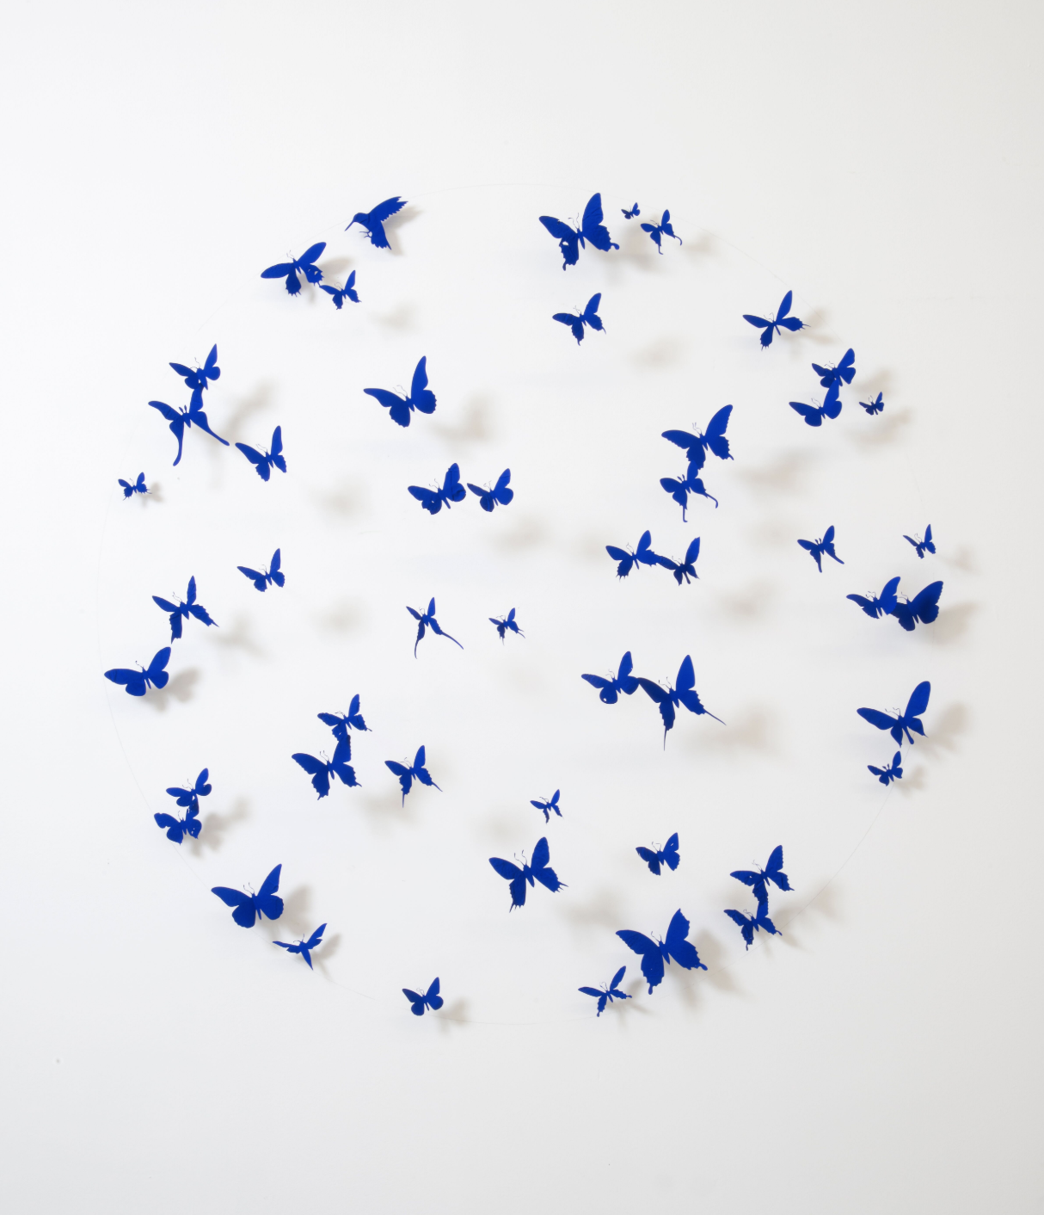

Paul Villinski, *Compass*, 2015, Found aluminum cans, wire, flashe, 48 x 48 x 6 inches

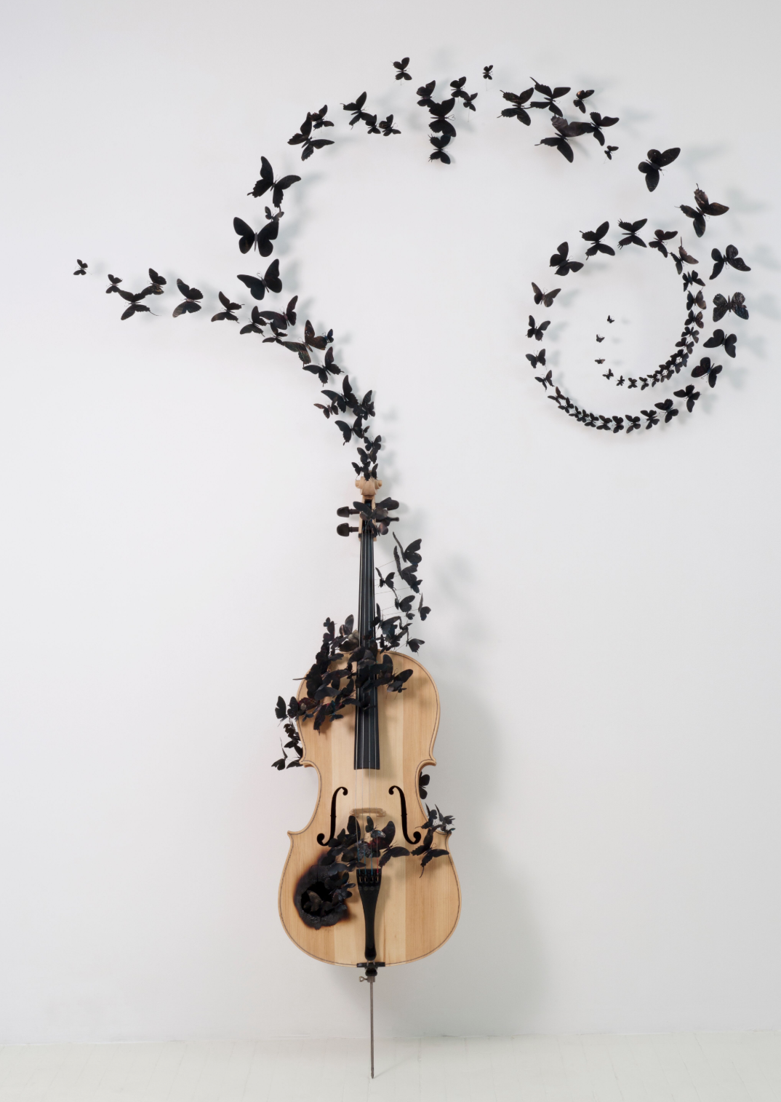

Paul Villinski, *Fable*, 2010, Cello, aluminum (found cans), soot, wire, 96 x 65 x 16 inches



Paul Villinski, *Wave*, 2017, found aluminum cans, gold leaf, stainless steel wire, enamel, 60 x 144 x 7 inches